**Literature Review Reflections**

**by Vasilisa Lukashevich**

**(Unit 7 Research Methods and Professional Practice May 2023)**

For the first time during my studying process at the University of Essex, I failed an assignment. This occurred in this specific module where I had chosen the topic for the Literature Review: "Implementing Deep Learning tools and techniques to detect political misinformation on social media platforms."

From the outset, I recognised the necessity of reviewing a substantial amount of information sources in order to produce a profound and meaningful secondary research. I studied over 20 papers covering diverse topics, ranging from the meaning of propaganda and political misinformation to the accuracy of Geometric Deep Learning and practical examples of implementing AI tools.

However, I overlooked a very important aspect of academic writing. In certain explanations, I unintentionally included parts of sentences from related sources without proper citation. Although I mentioned all these papers in the reference list, it became apparent that this approach was highly inappropriate. The Turnitin software flagged 30% of the text as non-original, even though, in the Literature Review format, this indicator should ideally be between 0% and 10% (despite the fact that Academic integrity only accounts for 10% of the overall grade). Due to the lack of my own academic voice in writing, I failed to meet one of the most crucial criteria - Knowledge and understanding (30% of the overall grade).

According to tutors, another issue with my review is its predominantly descriptive nature, lacking critical analysis. I am advised to incorporate more pros and cons into the discussion, not solely relying on comparing model results, but also expressing my own perspective on the primary issue highlighted in the topic.

I had been working on the assignment following my intuition, but I later realised that resources like Sage Research Methods could be extremely beneficial for professional researchers, especially when conducting multiple research projects simultaneously.

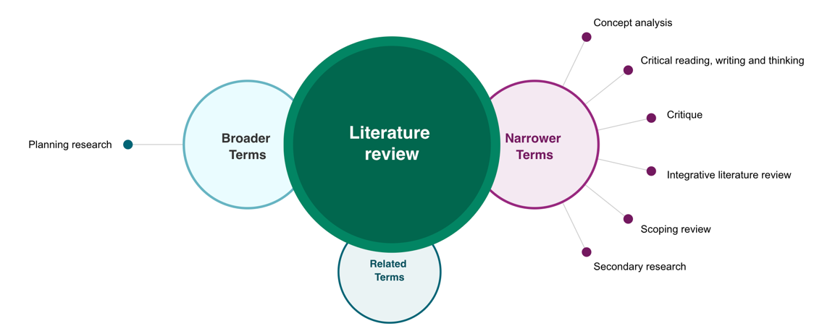

*Illustration 1. Literature Review Term Map (methods.sagepub.com/methods-map/literature-review)*

Thanks to Sage maps, I came to understand that critical thinking and critique are not the same. For example, a critical review is generally more objective and neutral in tone, while a critique reflects personal opinions and interpretations. Like musicians say, the difference between a review and a critique lies in the latter's focus on the writer's opinion and taste (Liebman, 2023).

In the process of delving deeper into the essence of critical analysis, I found the scheme below very explanatory (Spector & Ma, 2019). Before some of these concepts got mixed up in my head, and Analysis seemed to be the same as Synthesis or similar to Explanation in a different context. The picture is clear as a part of agreement between specialists in a specific field. However, I was a little surprised that a Beginner is able to provide an Explanation in this hierarchy.

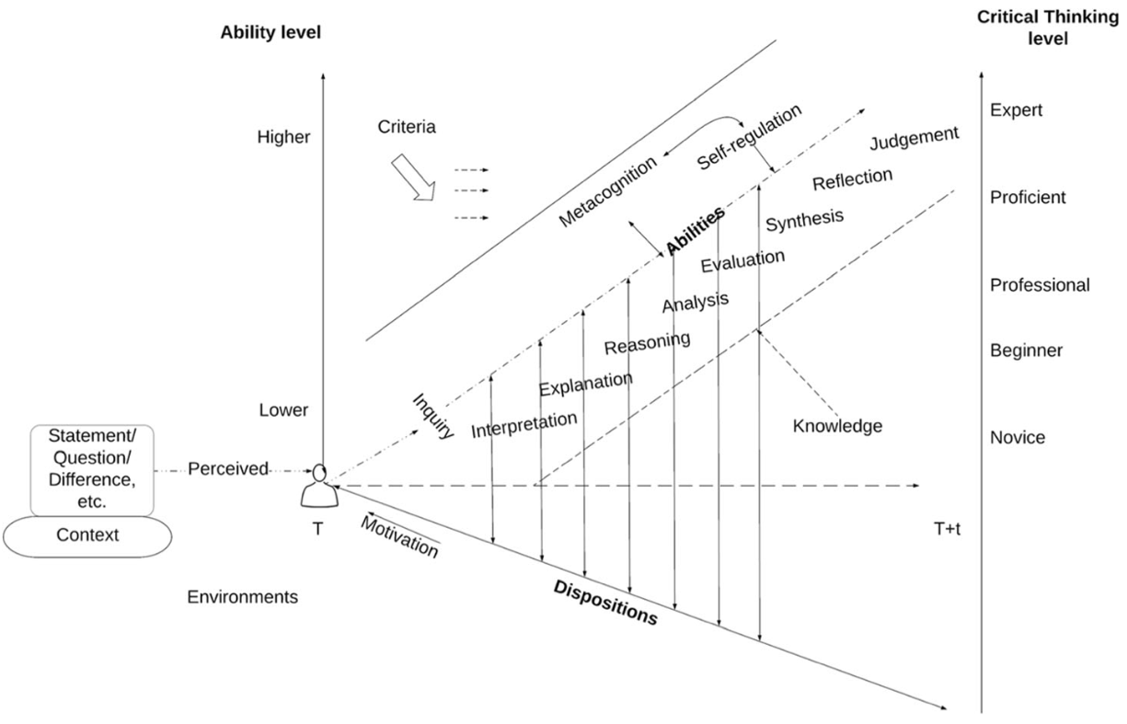

*Illustration 2. A framework of critical thinking (Spector & Ma, 2019)*

Theoretically, critical writing involves actively engaging in critical thinking and serves as a means to convey the results of that critical thinking (Ideas, 2011). From a practical standpoint, McKinsey experts define critical thinking as a desired level of proficiency where individuals can effectively address complex problems by breaking them down, identifying root causes, and finding suitable solutions (Dondi et al., 2021).

In conclusion, some scholars believe that critique from colleagues is like necessary pressure that helps produce brilliants, while others argue that for 'truthful' scientific theory criticisms, it feels more like a weak wind; however, criticisms should always be grounded in theory (Black et al., 2022).

**References**

Dondi, M., Klier, J., Panier, F. & Schubert, J. (2021) Defining the skills citizens will need in the future world of work. McKinsey & Company, 25.

Ideas, E. (2011) The Professor's Guide to Integrating Writing, Critical Thinking, and Active Learning in the Classroom.

Liebman, D. The Critic Dilemma: Criticism vs. Review. Available from: https://davidliebman.com/home/ed_articles/the-critic-dilemma-criticism-vs-review/ [Accessed 21 Jul 2023]

Sage (2021) Sage Research Methods: Methods Map.

Spector, J.M. & Ma, S. (2019) Inquiry and critical thinking skills for the next generation: from artificial intelligence back to human intelligence. *Smart Learning Environments, 6*(1), pp.1-11.